MEET JACK
7 March 2018
by Carol Bower Foote

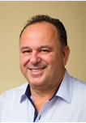
Jack Hirsch. Winner of this year’s “Spirit of Rio Vista” award to be presented by RioVision at the Chamber of Commerce Awards Banquet this Friday evening, March 9th. Jack doesn’t live in Rio Vista, but he found here something he calls ‘special and rare’ and worth keeping.
With his partners, Jack purchased and has been renovating the old Hotel Rio Vista at Main and 2nd, and the historic Sidwell/Ram Hotel at 2nd and Montezuma. Both spaces will house retail businesses and apartments, including 6-8 expanded units which Jack plans to offer as high end Air B&B rentals for visitors to our area.
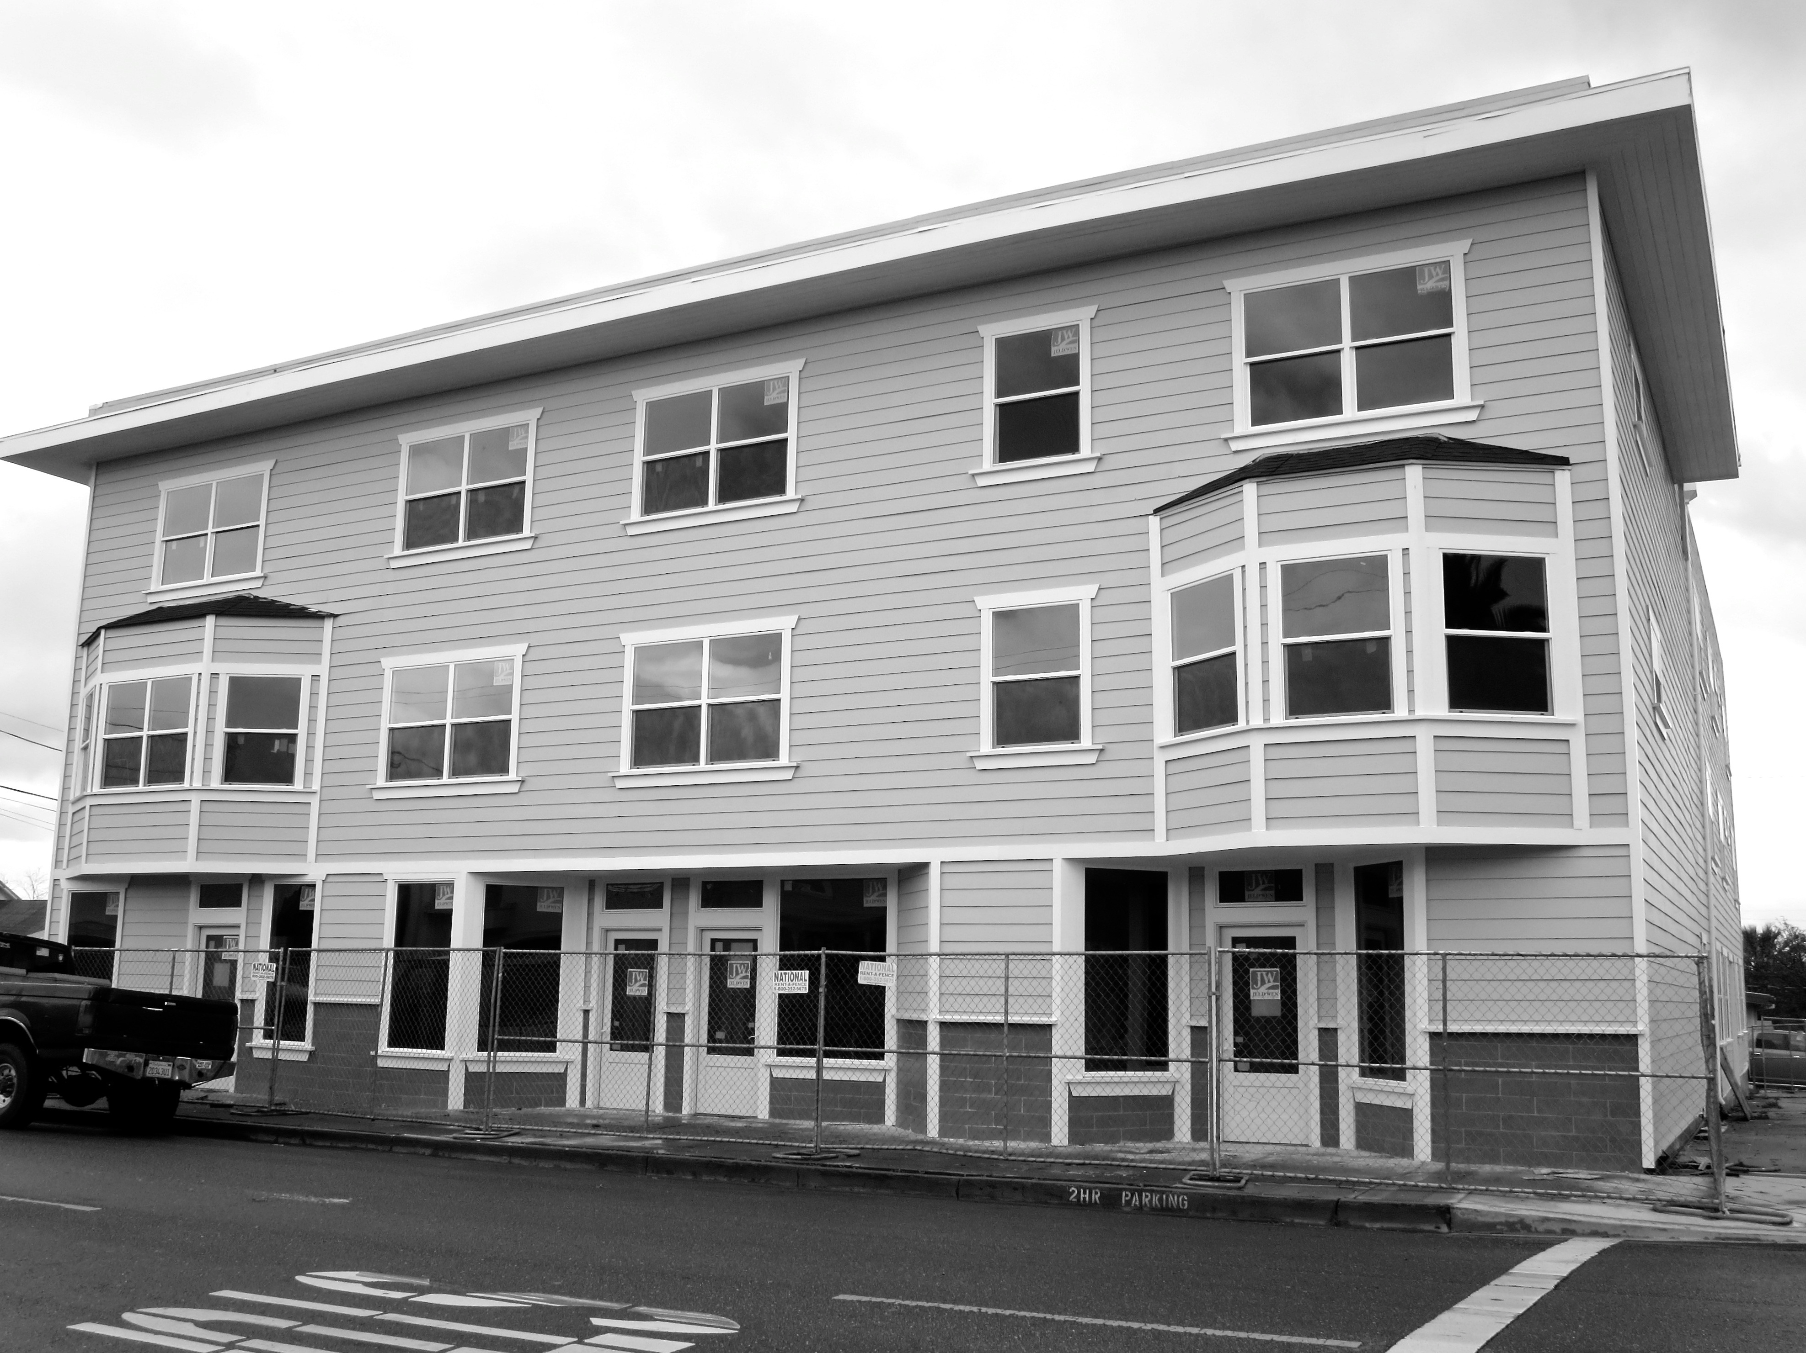
When asked what drew him to invest in Rio Vista, Jack’s reply came quickly. He fell in love with the buildings and the town as historic locations. But what drew him into a relationship with this town is its people and culture which to him feels like a step back in time to when folks were warm, helpful, polite, cooperative, and just nice, genuine human beings. With his broad dealings in the San Francisco Bay Area, to him, this is something precious that has been lost along the way, but not here. Before he purchased, he spent a day downtown and hours with the city Building & Planning Departments. He found our commissioners and city officials to be refreshing: receptive and easy to do business with.
For the Ram/Sidwell building, Jack was enthusiastic about staying true to the city-approved plan to renovate the exterior in its original style of the 1920^{s.} Although his projects usually work with building interiors prior to the exteriors, out of appreciation for Rio Vista’s downtown, he gave the exteriors their badly needed facelift first. Finding contractors in a boom expansion time in the Bay Area has been a challenge; Jack and his partners have put hours into finding the right people to do a quality job at a fair price, reaching out to Sacramento, Stockton, and the Central Valley.
Jack is not a developer, but a real estate broker and investor (Realty World-Hirsch and Associates) who partners with his uncle, Maurice Avecassis, on most projects, and on the Rio Vista Hotel with Evan Powell as well. Born in Israel, Jack has been a California resident since the age of 6. He is a family man living in the Bay Area with two high school boys, one of whom will attend college next year. He has other dreams in this town – one is to provide a restaurant facility on the same block as the old Hotel Rio Vista and have a courtyard linking it to that building. If the Air B&B units do well, he could convert other units over to that usage to expand guest lodging available in town. Jack is an ally in promoting our little town to other businesses and potential investors. You can meet Jack Friday evening at the Chamber of Commerce banquet.
***
Don’t miss the presentation at the RioVision General Meeting on March 12th @ 5:30pm on the joint venture between Habitat for Humanity and Community Action North Bay to build and operate a permanent home for 6-8 veterans near the Veterans Memorial Building here in town.
This is a national pilot project for Habitat which until now has been focused on single family homes. American Legion Post 178 will join Habitat and CAN-B in providing the current status of the project including financing, construction, and management, and will answer questions.

